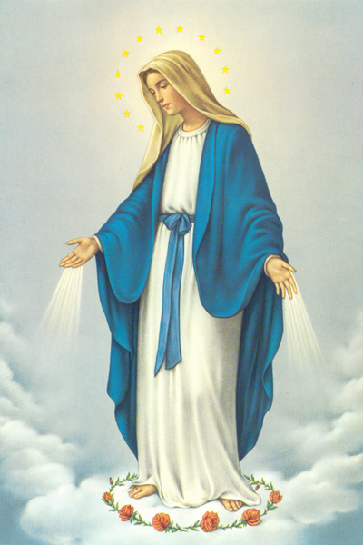
Our class saint is Saint Mary.
Her feast day is 1st January.
She is the patron saint of all human beings, especially young children.

