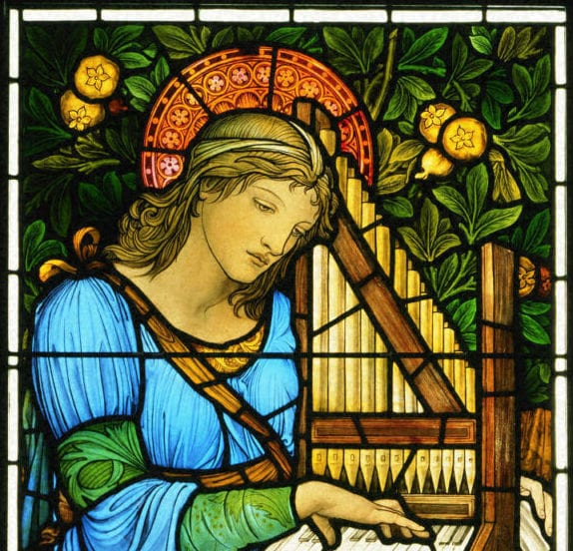
Our class saint is Saint Cecilia.
Her feast day is 22nd November.
She is the patron saint for music and blindness.

