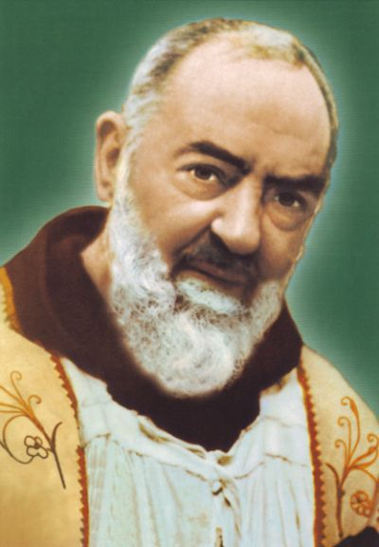
Our class saint is Saint Pius of Pietrelcina (known as Padre Pio.) His feast day is 23rd September.
He is the patron saint of the stress relief and teenagers.

