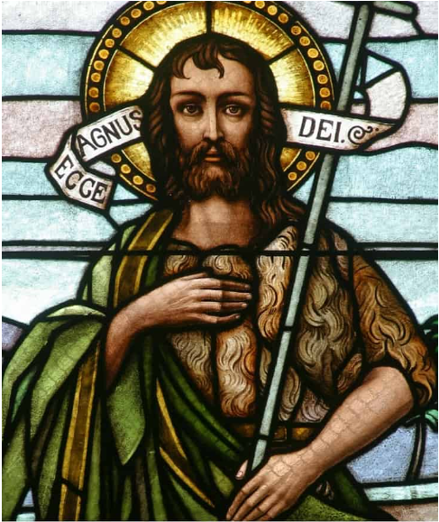
Our class saint is Saint John the Baptist.
His feast day is 24th June.
He is the patron saint of baptism and conversion to faith.

